Date & Time Walkthrough Performed: | October 20, 2025
Client Attendees (including Role): | Jamie Blake (manager- Purchasing Department)
Audit Team Attendees: | Your Name (Audit staff)  Kim Reynolds (senior auditor)

Purpose/Procedure: The walkthrough of ABC Company’s purchasing process was performed in order to gain a further understanding of the existing processes and controls. Date, time and attendees of the purchasing process walkthrough are summarized above.

The purchasing process and control details gathered during the walkthrough are documented below, along with the supporting screenshots.

Results: Documented in detail, as follows:

A) Walkthrough of Purchase Request Portal:
- Purchase Policy
Per Jamie Blake (Purchasing Department Manager who conducted the walkthrough), the Risk Management department reviews and updates the Purchase Policy annually. Updates are reviewed and approved by the CFO before the latest version of the Policy is disseminated for use (via posting to internal website).
The IT Department is notified by Risk Department of any updates required as a result of the policy update cycle. Each year, employees are required to attest to receipt of the new version of the Purchase Policy, and must complete a short quiz to verify their knowledge of the internal process.

- Submitting a Purchase Request
For purchases which exceed the pre-approval thresholds (outlined within the Purchase Policy), employees will login to the Purchase Request Portal, and will then follow the below steps to populate (and submit) their purchase request.

Upon login, employee is taken to the “Requestor View” of the Portal, where all required details must be populated:
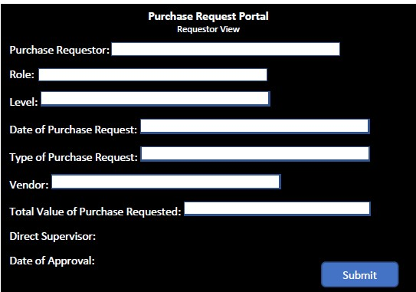

All fields which include a white box must be populated in order for the purchase request to be considered complete.

If an incomplete purchase request is attempted to be submitted to the Portal, an automated control precludes processing, as shown below.

Completeness Control (Portal Rejects a Request if all Required Fields are not Populated):

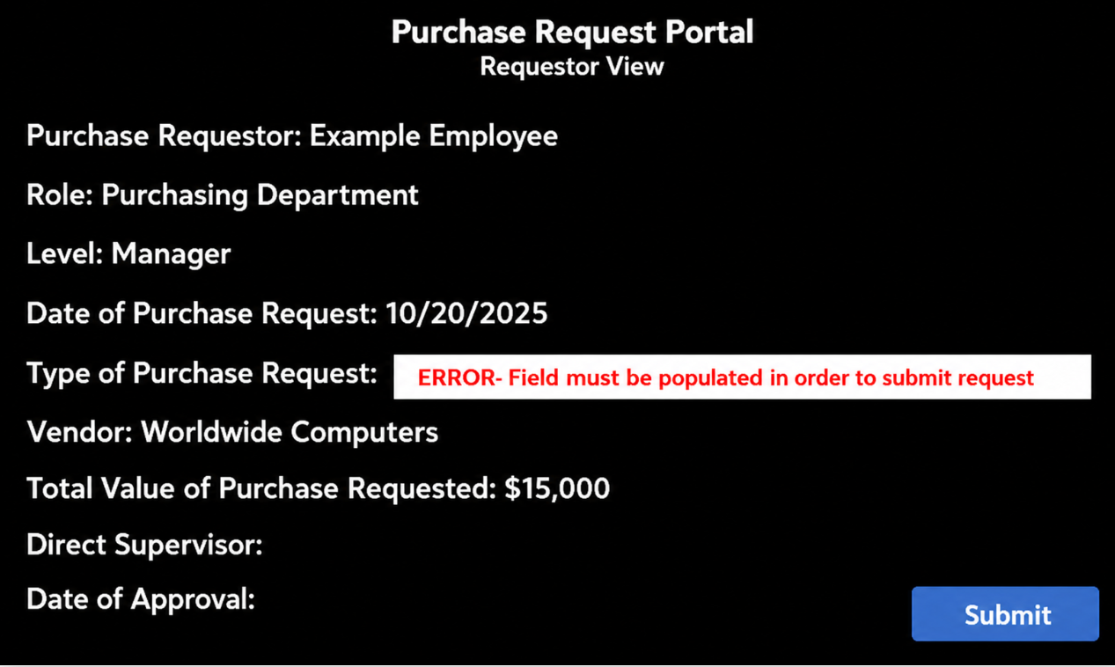

After all information has been provided, and the request is submitted, the Portal provides the requestor with confirmation, as shown below.

Notice of Request Submission:
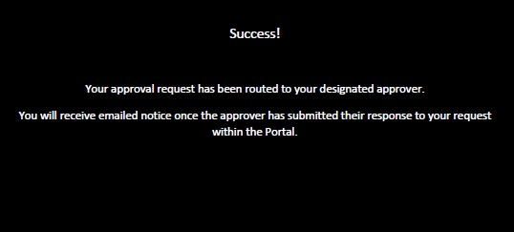

3) Purchase Review/Approval Process
Once a request is submitted within the Portal, the Portal automatically provides emailed notice to the assigned reviewer, as shown below. The reviewer is assigned via the Portal’s internal organizational chart, as discussed later in the walkthrough.

Emailed Notice of Required Review:
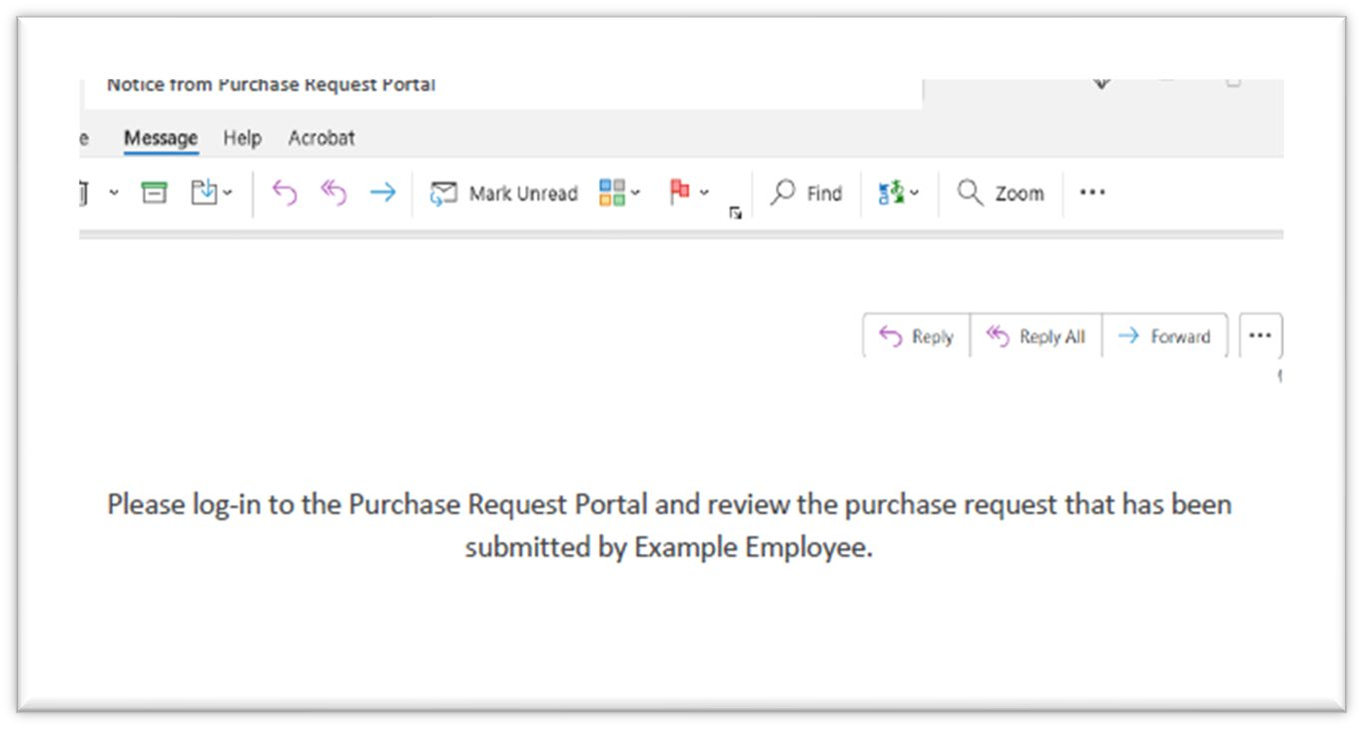

The reviewer logs into the Portal and select “Reviewer View” from the Portal dashboard to view the request. They then select “Approve” or “Deny” (by clicking on either of the two buttons), and then click “Submit” to process their review decision.

Red text (shown at the top of the Portal screen) confirms that the reviewer’s decision has been processed. This triggers an automated email (to the requestor) which provides notice of the reviewer’s decision.

Screenshots taken from the review/approval (denial) process walkthrough are shown as follows:

“Reviewer View” of Portal (to provide review decision):

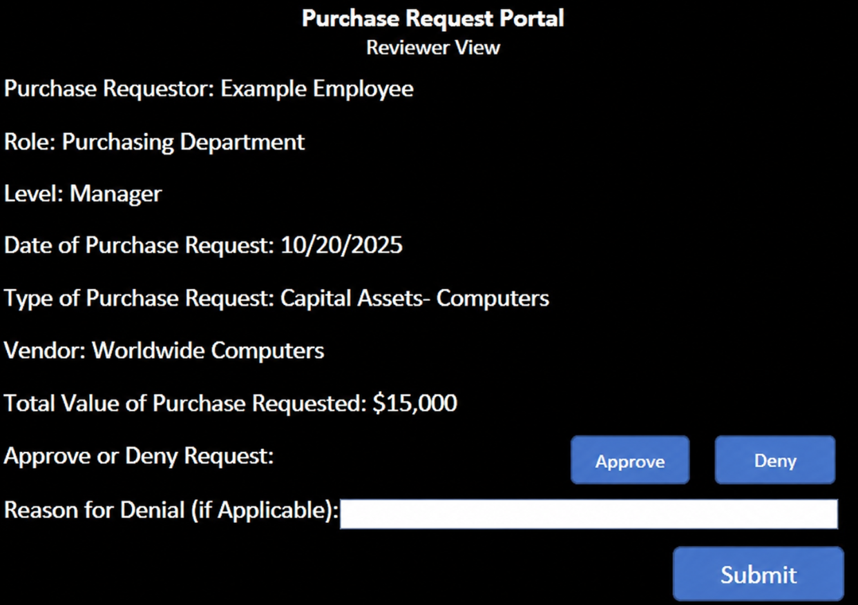

“Reviewer View”- Confirmation of Denial (After Decision is Submitted):

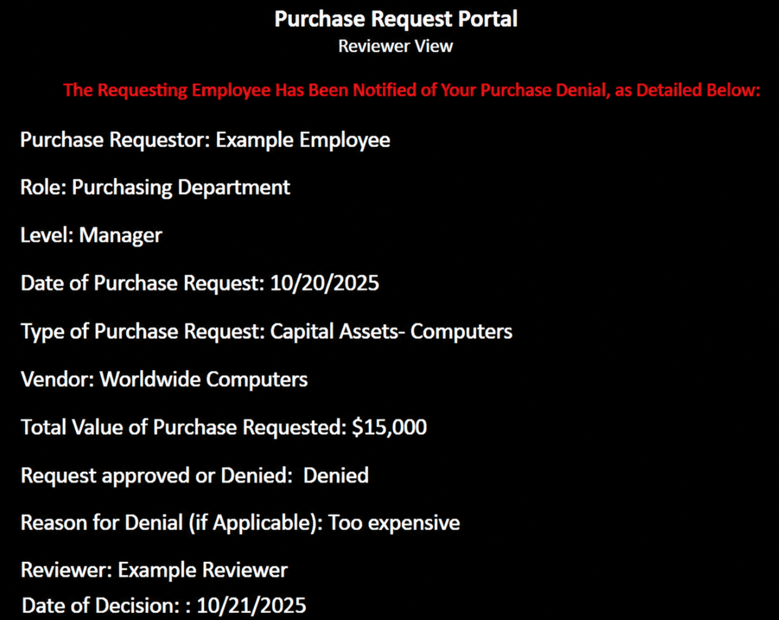

“Reviewer View”- Confirmation of Approval (After Decision is Submitted):

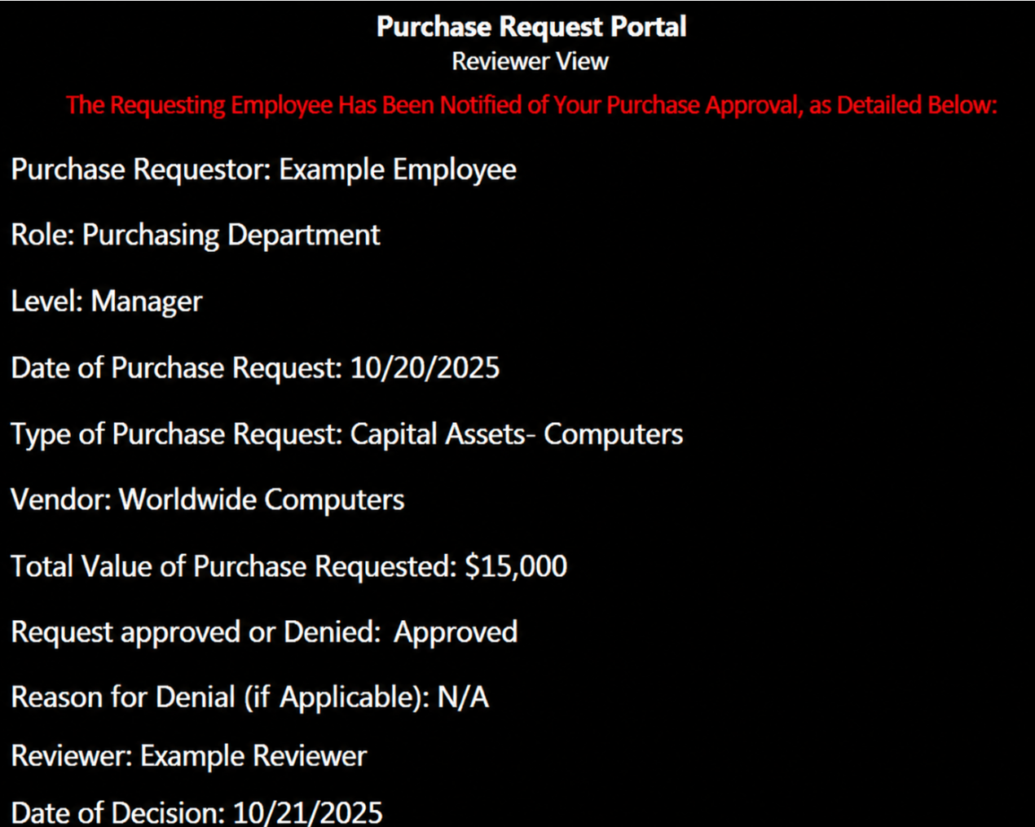

Automated Notice of Denial (Email Sent to Requestor):
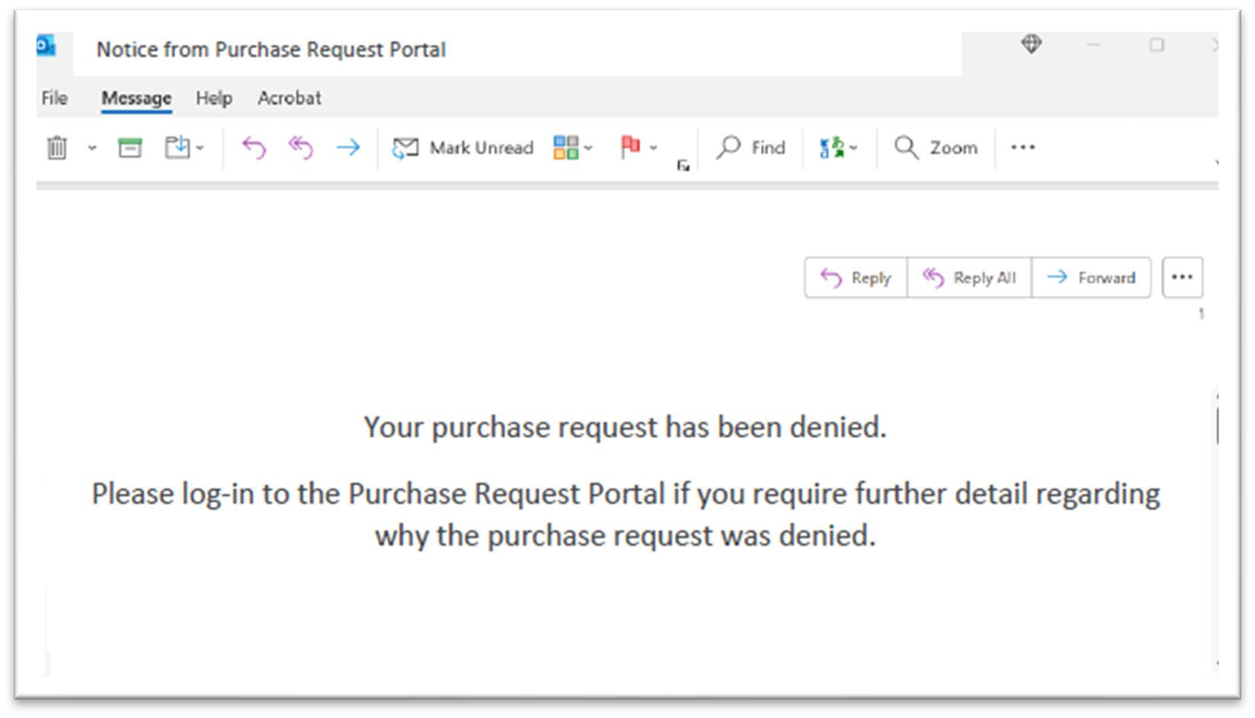

Automated Notice of Approval (Email Sent to Requestor):
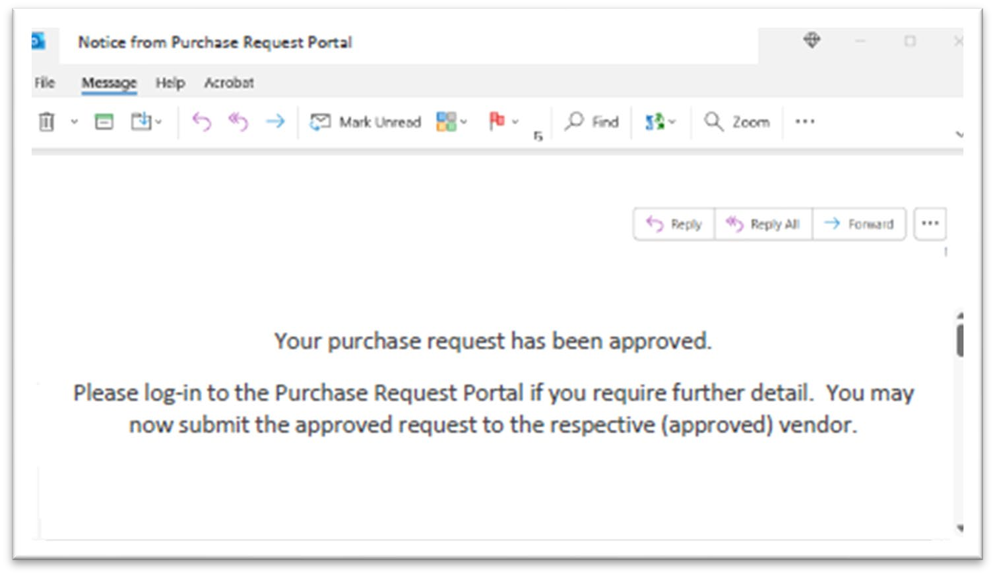

- Making a Purchase
Under the current process, employees own the responsibility to ensure that their purchases (made on behalf of the company) comply with the internal Policy. As such, employees are tasked with obtaining pre-approvals (when required by internal Policy) before the purchase is made.

POTENTIAL CONTROL GAP NOTED- Relates to finding noted within test of details performed in Task 1 (Purchase made prior to employee obtaining required pre-approval).

See related detail within Section B (Subsection 5) of this document.

- Archived Records
All purchase approvals/denials are archived within the Purchase Request Portal, and can be accessed via the “Archived Records” option within the Portal dashboard. All records within the Portal are retained perpetually.

Archived records include previously requested purchases, as well as any approvals/denials previously provided, as described below:

“Archived Records” View of Denial:

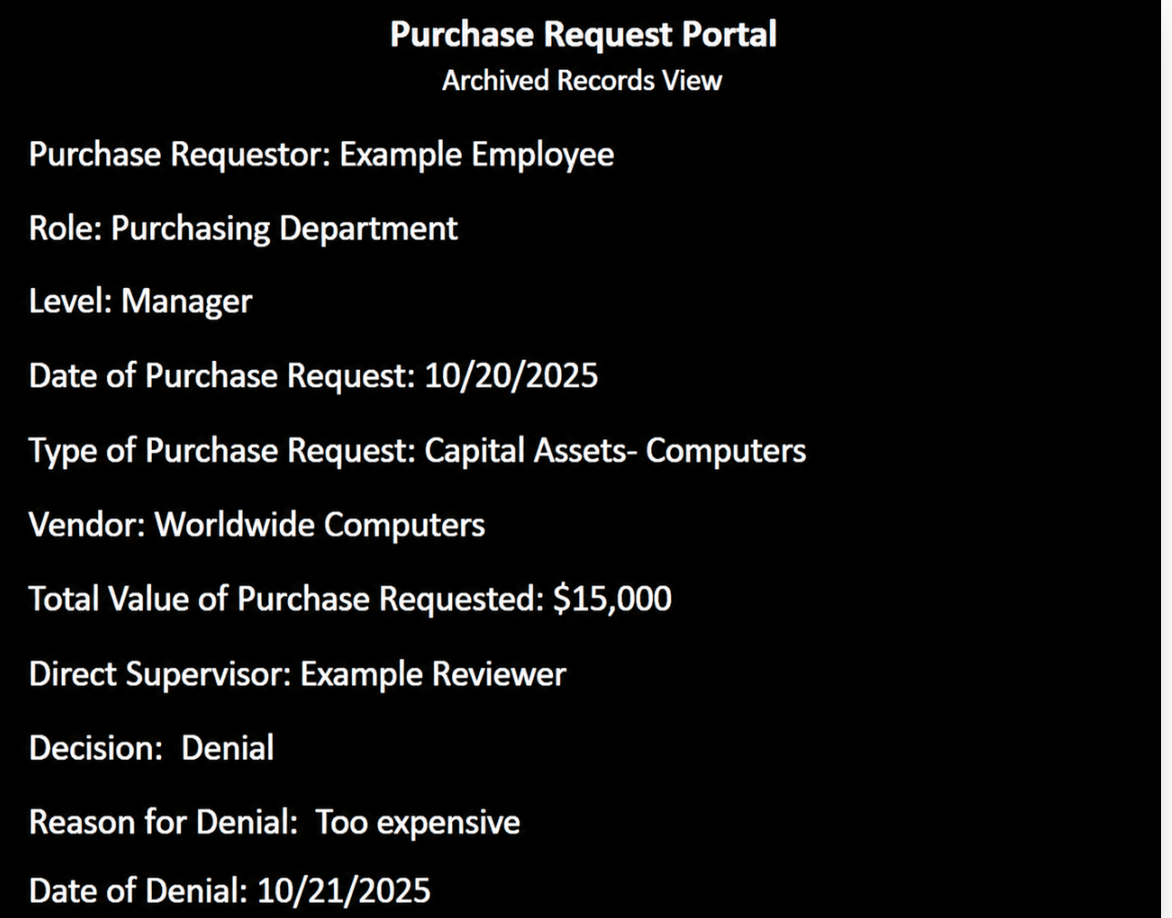

“Archived Records” View of Approval:
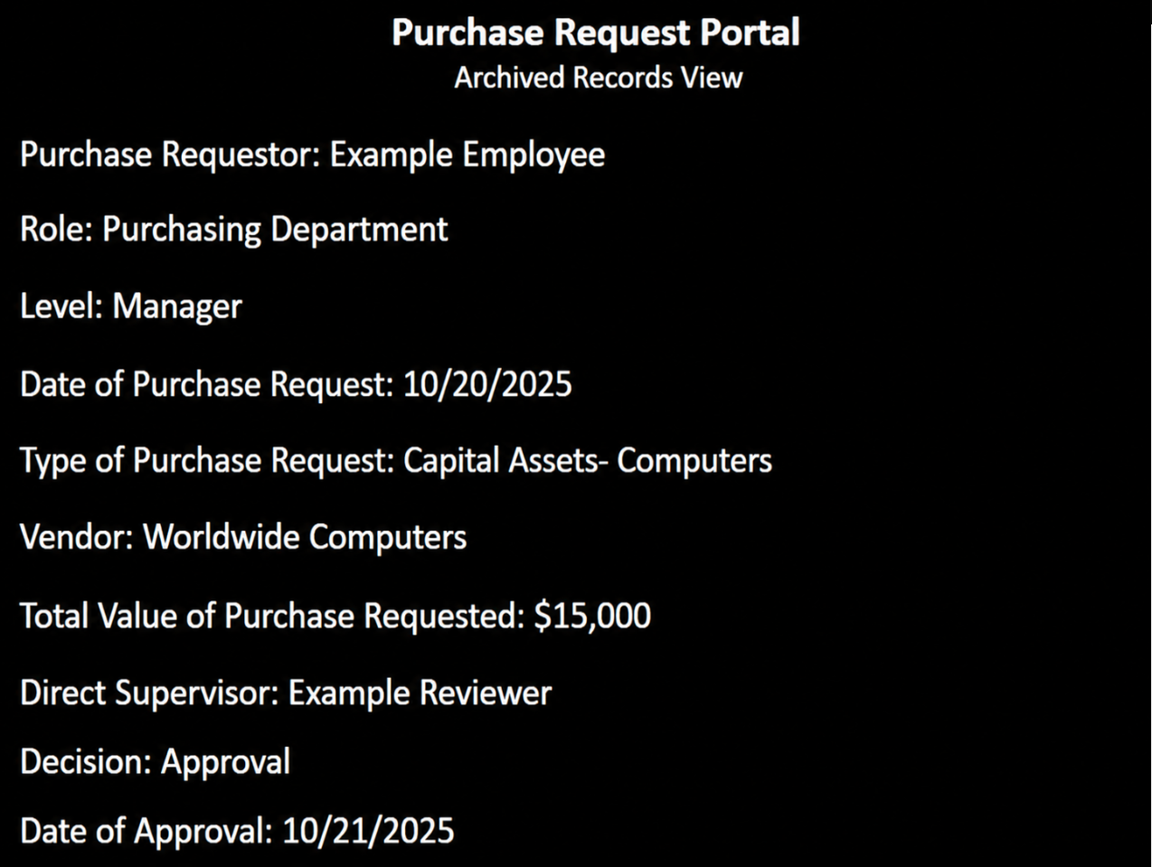

- Table of Employee Supervisors (Org Chart within Portal)
Within five business days of the annual promotion cycle, updates are made to the Organizational Chart within the Purchase Request Portal (as required by internal policy). The chart is labeled “Table of Employee Supervisors” within the Portal.

The HR Department provides the IT Department with the updated Organizational Chart, and the IT Department reviews/updates the existing chart within the Portal, where necessary. In order to implement the changes within the Portal, the following steps are undertaken:

Note: The below example shows the update of Tyler Day’s supervisor from Dave White to
Mike Jones

“Administrative View” of Table of Employee Supervisors (Greyed/Locked):
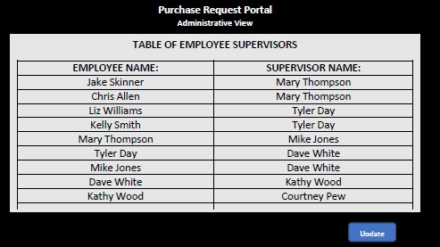

“Administrative View” of Table of Employee Supervisors (Whitened/Editable):
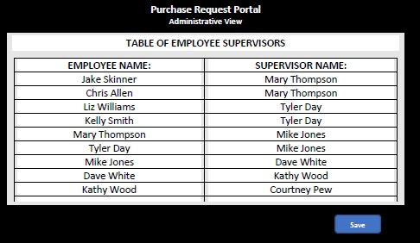

“Administrative View” of Table of Employee Supervisors (Locked view with Changes Saved):
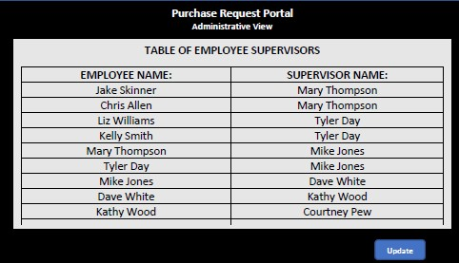

B) Open Questions Follow-Up:

Note: Questions provided to client shown in black, responses discussed during walkthrough meeting shown in blue, with follow-up items and potential findings shown in red.

- Process & Control Changes (Which Have Occurred Since Prior Year Audit Period):
  - Please confirm whether the process to review and update the Purchase Policy is the same as in the prior audit period Confirmed- (Reviewed by Risk Management, approved by CFO on an annual basis)
  - What are the changes to Purchase Request Portal during the audit period (i.e. planned maintenance, as a result of the most recent Purchasing Policy update cycle, etc.)? No major changes noted
  - Have there been any changes to key personnel (as they relate to the purchasing process and controls during the audit period)? No major changes noted for the current audit period.

Follow-up with IT and HR Departments: Per response received, HR Department should notify IT
Department immediately upon a new hire, or when an employee leaves the company. The IT Department team lead then applies the update immediately to the Portal,

POTENTIAL CONTROL GAP NOTED- Relates to finding noted within test of details performed in Task 1 (Approval assigned to the wrong supervisor)

o If so, when did those changes occur, and how were respective systems/processes updated as a result? Follow-up with IT and HR Departments

- Purchase Request Portal:
a) Portal Issue Reporting:
    - How are issues with the Portal typically identified/reported? End-users of the Portal can escalate any issues directly to the IT Department
    - Who are issues reported to? IT Department
    - How do stakeholders know where to report issues? IT Department publishes direct line in company-wide (internal) websites
    - What is done after an issue is reported? Follow-up with IT Department • How often is the Purchase Request Portal tested?
    - Who performs those tests?
    - What were the results of the last test(s) performed?
Follow-up with IT Department & Internal Audit Team (for three above questions)

b) Purchase Approval Assignments (System Maintenance):
    - How is the organizational chart within the Portal updated for each promotion cycle? HR Department provides updated Organizational Chart to the IT Department team leads, who then apply the updates within the Portal (via Administrative View).

Timing of control described as five days from the end of the internal promotion cycle.

    - Who is assigned responsibility to make those updates? IT Department (team leads)

    - When are they performed? Within five days of the conclusion of the internal promotions cycle (as noted above)

    - What documentation exists to verify that the control was performed in a complete and timely manner? Follow-up with IT Department

- Approved Vendor Listing:
  - Does ABC Company employ an Approved Vendor Listing (to ensure employee purchases are only made to approved vendors)? No, not currently
  - How does ABC Company ensure that the purchases are made to third-party (unrelated) vendors? The vendor is briefly reviewed by the direct supervisor as part of their purchase approval/denial process POTENTIAL CONTROL GAP NOTED (Vendors are not vetted before employees can submit purchases)

- Prior-Year Exception(s) Follow-up:
  - Last year, an issue was identified in some purchase approval documentation not being able to be retrieved/provided for audit support purposes (Noted that these exceptions occurred before the Purchase Request Portal was phased-in).

Please explain the Purchasing Portal process to retain/archive the electronically provided approvals, including:
      - How long is the approval archived within the system? All historical approvals/denials are archived
      - In what instances (if any) can data be retroactively altered (i.e. to pre-date approvals)? The record is locked once the reviewer submits their decision. It is not possible to alter records once this has occurred.
      - What are the controls surrounding access for the documented approvals? “Archived Records” view (within the Portal) allows an employee to view all of their historical purchase requests, and any requests for which they provided review and approval/denial

- Approval Timing:
• What controls exist to ensure that an employee does not externally submit a purchase to a vendor without the prerequisite, documented approval of such purchase? All employees agree to comply with the Purchasing Policy, which outlines the requirement that preapproval be obtained before a qualifying purchase is made.

POTENTIAL CONTROL GAP NOTED- Relates to finding noted within test of details performed in Task 1 (Purchase made prior to employee obtaining required pre-approval).

See additional follow-up within Section A (Subsection 4) of this document

- Disclosure of Issues Which Occurred During the Audit Period:
No issues noted for any of the items listed below
  - Have there been any issues of control gaps (i.e. points in the purchasing process which were risks were not adequately covered by an appropriate control)?
  - Have there been any issues in control functionality (i.e. controls did not function as designed, and therefore did not identify issues for which the control was designed to detect/prevent)?
  - Has your team identified any purchases which were submitted to the vendor prior to obtaining the required approvals (per the Purchasing Policy)?

- Internal Reviews (of Purchasing Process & Controls) Performed During Audit Period: Follow-up with Internal Audit and IT Departments
  - Have there been any internal reviews (i.e. client’s internal audit team reviewed process/controls, finance team reviewed process/controls, etc.) which cover the current audit period?
  - How often are the purchasing process controls reviewed/tested/updated?
  - When did the last updates to these controls occur?
  - When did the last internal tests of these controls occur (please provide supporting documentation)
  - Have any instances of control gaps or failures (i.e. where a control failed to identify an issue or inaccuracy in the purchasing process, or where a control area was identified for enhancement)?

- Initial (Drafted) Exceptions Noted as a Result of Current Year Fieldwork Performed:
    - Purchase approval obtained from an employee other than the requestor’s direct supervisor Client verified that an update to the internal Organizational Chart (resulting from an existing employee changing departments) was not updated for/reflected within the Portal’s Table of Employee Supervisors. Issue noted.
    - Purchase was made with vendor before required pre-approval was obtained Client described that this purchase was made by a high-level employee to make an urgent reservation (related to reserving a venue for the company’s holiday party). Issue noted.

Conclusion: Based on the results documented above, it appears that several control issues exist, including those outlined as follows:

-Vendors are not adequately vetted before employees are able to make purchases from them

-Inadequate controls exist to ensure that all required pre-approvals have been obtained before a purchase is made with the vendor (relates to finding carried over from task 1)

-Internal process to update the Table of Employee Supervisors within the Purchase Request Portal does not appear to be functioning adequately (relates to finding carried over from task 1)

Based on the above, control weaknesses exist. Additional testing of details deemed necessary.

